

E-commerce Website Development Report

Kevin Zhang,Adel Leshob,Hugo Dos Reis



June 1, 2025

Seoul National University of Science and Technology (SeoulTech)

232 Gongneung-ro, Nowon-gu, Seoul, South Korea

| **Section** |  |  |  |  |  |  |  |  |  |  |  |  |  |  |  |  |  |  |  |  |  |  |  |  |  |  |  |  |  |  |  |  |  |  |  |  |  |  |  |  |  |  |  |  |  |  |  |  |  |  |  | **Page** |
| --- | --- | --- | --- | --- | --- | --- | --- | --- | --- | --- | --- | --- | --- | --- | --- | --- | --- | --- | --- | --- | --- | --- | --- | --- | --- | --- | --- | --- | --- | --- | --- | --- | --- | --- | --- | --- | --- | --- | --- | --- | --- | --- | --- | --- | --- | --- | --- | --- | --- | --- | --- | --- |
| **1. Project Overview** |  |  |  |  |  |  |  |  |  |  |  |  |  |  |  |  |  |  |  |  |  |  |  |  |  |  |  |  |  |  |  |  |  |  |  |  |  |  |  |  |  |  |  |  |  |  |  |  |  |  |  | **2** |
| **1.1 Context and Objectives** |  |  |  |  |  |  |  |  |  |  |  |  |  |  |  |  |  |  |  |  |  |  |  |  |  |  |  |  |  |  |  |  |  |  |  |  |  |  |  |  |  |  |  |  |  |  |  |  |  |  |  | **2** |
| **1.2 Scope and Expected Outcomes** |  |  |  |  |  |  |  |  |  |  |  |  |  |  |  |  |  |  |  |  |  |  |  |  |  |  |  |  |  |  |  |  |  |  |  |  |  |  |  |  |  |  |  |  |  |  |  |  |  |  |  | **2** |
| **2. Architecture and Design** |  |  |  |  |  |  |  |  |  |  |  |  |  |  |  |  |  |  |  |  |  |  |  |  |  |  |  |  |  |  |  |  |  |  |  |  |  |  |  |  |  |  |  |  |  |  |  |  |  |  |  | **3-5** |
| **2.1 Architecture Overview** |  |  |  |  |  |  |  |  |  |  |  |  |  |  |  |  |  |  |  |  |  |  |  |  |  |  |  |  |  |  |  |  |  |  |  |  |  |  |  |  |  |  |  |  |  |  |  |  |  |  |  | **3-4** |
| **2.2 Design** |  |  |  |  |  |  |  |  |  |  |  |  |  |  |  |  |  |  |  |  |  |  |  |  |  |  |  |  |  |  |  |  |  |  |  |  |  |  |  |  |  |  |  |  |  |  |  |  |  |  |  | **4-5** |
| **3. Key Features and Technologies** |  |  |  |  |  |  |  |  |  |  |  |  |  |  |  |  |  |  |  |  |  |  |  |  |  |  |  |  |  |  |  |  |  |  |  |  |  |  |  |  |  |  |  |  |  |  |  |  |  |  |  | **6-7** |
| **3.1 Main Functionalities** |  |  |  |  |  |  |  |  |  |  |  |  |  |  |  |  |  |  |  |  |  |  |  |  |  |  |  |  |  |  |  |  |  |  |  |  |  |  |  |  |  |  |  |  |  |  |  |  |  |  |  | **6** |
| **3.2 Technologies and Tools** |  |  |  |  |  |  |  |  |  |  |  |  |  |  |  |  |  |  |  |  |  |  |  |  |  |  |  |  |  |  |  |  |  |  |  |  |  |  |  |  |  |  |  |  |  |  |  |  |  |  |  | **7** |
| **4. Challenges and Solutions** |  |  |  |  |  |  |  |  |  |  |  |  |  |  |  |  |  |  |  |  |  |  |  |  |  |  |  |  |  |  |  |  |  |  |  |  |  |  |  |  |  |  |  |  |  |  |  |  |  |  |  | **8** |
| **4.1 Problems Encountered** |  |  |  |  |  |  |  |  |  |  |  |  |  |  |  |  |  |  |  |  |  |  |  |  |  |  |  |  |  |  |  |  |  |  |  |  |  |  |  |  |  |  |  |  |  |  |  |  |  |  |  | **8** |
| **4.2 Solutions Implemented** |  |  |  |  |  |  |  |  |  |  |  |  |  |  |  |  |  |  |  |  |  |  |  |  |  |  |  |  |  |  |  |  |  |  |  |  |  |  |  |  |  |  |  |  |  |  |  |  |  |  |  | **8** |
| **5. Individual Contributions** |  |  |  |  |  |  |  |  |  |  |  |  |  |  |  |  |  |  |  |  |  |  |  |  |  |  |  |  |  |  |  |  |  |  |  |  |  |  |  |  |  |  |  |  |  |  |  |  |  |  |  | **9-11** |
| **5.1 Team Member 1: Kevin Zhang** |  |  |  |  |  |  |  |  |  |  |  |  |  |  |  |  |  |  |  |  |  |  |  |  |  |  |  |  |  |  |  |  |  |  |  |  |  |  |  |  |  |  |  |  |  |  |  |  |  |  |  | **9** |
| **5.2 Team Member 2: Adel leshob** |  |  |  |  |  |  |  |  |  |  |  |  |  |  |  |  |  |  |  |  |  |  |  |  |  |  |  |  |  |  |  |  |  |  |  |  |  |  |  |  |  |  |  |  |  |  |  |  |  |  |  | **10** |
| **5.3 Team Member 3 Hugo Dos Res** |  |  |  |  |  |  |  |  |  |  |  |  |  |  |  |  |  |  |  |  |  |  |  |  |  |  |  |  |  |  |  |  |  |  |  |  |  |  |  |  |  |  |  |  |  |  |  |  |  |  |  | **11** |
| **6. Conclusion and Future Perspectives** |  |  |  |  |  |  |  |  |  |  |  |  |  |  |  |  |  |  |  |  |  |  |  |  |  |  |  |  |  |  |  |  |  |  |  |  |  |  |  |  |  |  |  |  |  |  |  |  |  |  |  | **12** |

**1. Project Overview**

**1.1 Context and Objectives**

This project involved designing and developing a fully functional e-commerce website as a group assignment. The main goal was to create a secure and user-friendly online shopping platform using Node.js and the Express framework, with SQLite as the database for persistent data storage. The core objective was to apply and integrate all the web development concepts learned throughout the course into a single, practical project, including modular code design, secure user authentication, and session management.

**1.2 Scope and Expected Outcomes**

The application aims to replicate core e-commerce functionalities expected in a real-world site. By the project’s completion, the team delivered a working prototype enabling users to:

* Register and log in securely
* Browse and search products
* Add, update, and remove items in a shopping cart
* Complete a simulated checkout process
* Persistently manage user and product data

This project also provided valuable experience in collaborative development, integrating front-end and back-end technologies, and implementing security measures in web applications.

**2. Architecture and Design**

**2.1 Architecture Overview**

The e-commerce project is structured following a classic client-server architecture comprising:

* **Frontend (Client):** User interface built with HTML, CSS, and JavaScript, enabling browsing, searching, cart management, and user authentication.
* **Backend (Server):** Server-side application responsible for business logic, user management, product handling, order processing, and database communication.
* **Database:** Relational storage (sqlLite) for product, user, order, and session data.
* **External Services:** Integration of a mock payment gateway to securely handle the checkout process.

This layered architecture ensures clear separation of concerns, improves maintainability, and facilitates future scalability.

**Image: System Architecture**

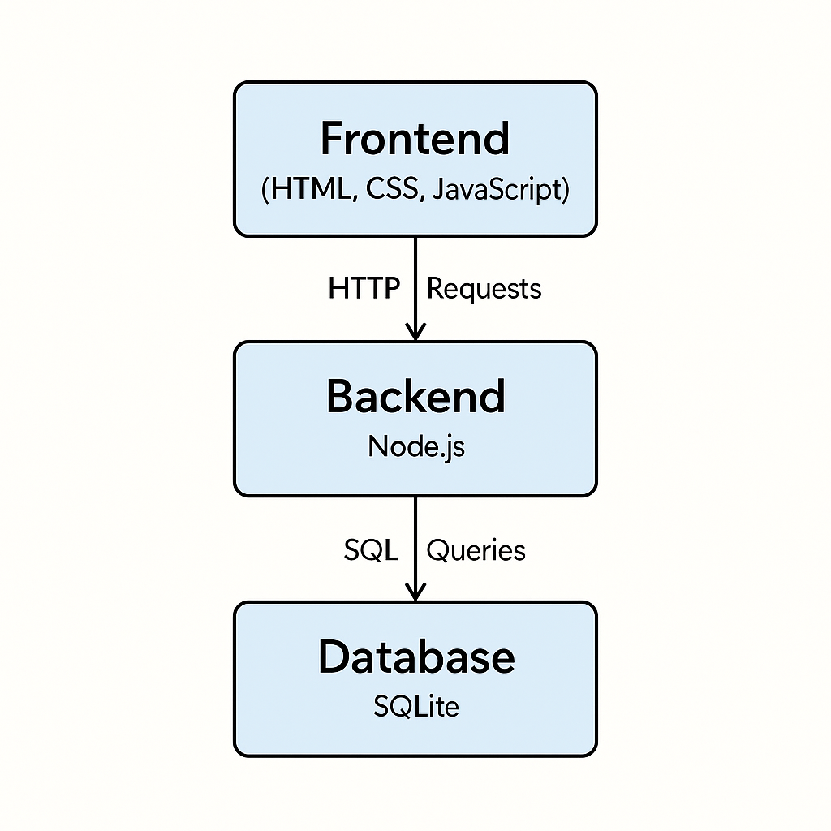

This diagram shows the main parts of the e-commerce app and how they work together. The front end talks to the back end, which handles user actions and connects to the database to store data.

**The Importance of Folder Structure**

A well-structured folder system is essential for keeping your project organized, readable, and easy to maintain. It helps teams collaborate efficiently, simplifies debugging, and ensures scalability as the project grows.

**Image: Files Architecture**

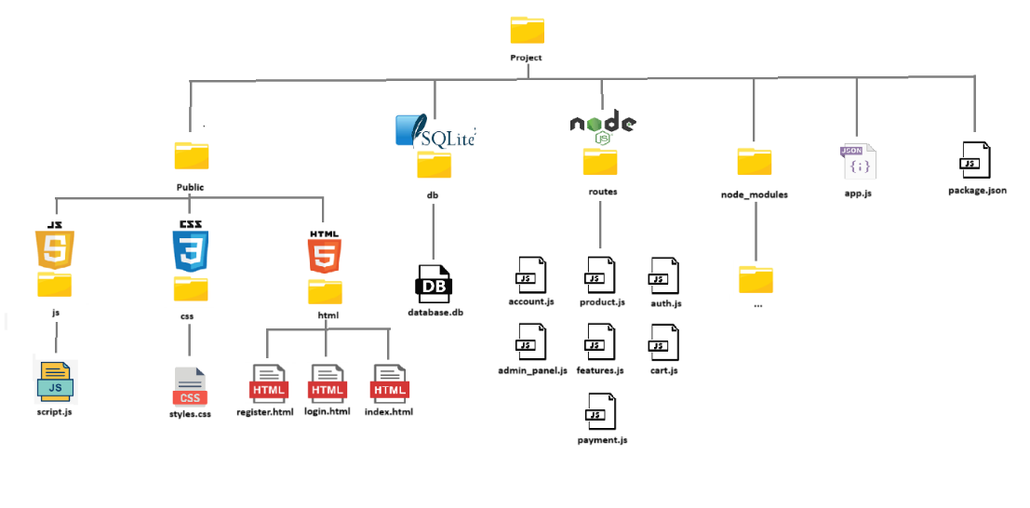

This structure shows how files are organized in our e-commerce website project. It separates code, assets, and configuration to keep the project clean and easy to manage.

**2.2 Design**

**About the E-commerce Website**

The e-commerce website features a clean and modern design with a homepage showcasing featured products and promotions. Users can browse a categorized product catalog, manage their cart, and complete purchases through a secure checkout. An admin panel allows product and order management, making the platform functional for both customers and administrators.

**Image: Website Overview**

**3. Key Features and Technologies**

**3.1 Main Functionalities**

This section highlights the main features of the e-commerce application and the key technologies used to build it. The focus is on usability, security, and performance.

**The main features of the application are:**

* **Homepage**: A landing page showcasing featured products, promotions, and a clear navigation menu.
* **Product Catalog**: Displays products with images, descriptions, and prices. Includes search and filtering options, and product categorization.
* **Shopping Cart**: Allows users to add, remove, and update items in their cart. Automatically calculates the total cost including taxes and shipping.
* **User Authentication**: Supports user registration, login, and profile management.
* **Checkout Process**: Provides a secure checkout process integrated with a mock payment gateway.
* **Admin Panel (Optional)**: Enables management of products, user accounts, and orders.

**Additional development goals included:**

* Writing clean, modular, and maintainable code.
* Implementing secure user authentication with password hashing using bcrypt.
* Managing user and product data through the SQLite database.
* Creating a responsive user interface for enhanced user experience.

**3.2 Technologies and Tools**

For the development of the e-commerce website, the following technologies and tools were used to ensure an efficient application:

* **JavaScript**: The core scripting language used to implement dynamic behavior and interactivity on the client side.
* **Node.js**: A JavaScript runtime environment used to build the server-side of the application, enabling fast and scalable back-end development.
* **Express**: A lightweight and flexible web framework for Node.js, used to simplify the creation of server-side logic, handle routing, and manage HTTP requests and responses efficiently.
* **HTML & CSS**: The foundational technologies for structuring and styling the web pages, ensuring a responsive and visually appealing user interface.
* **SQLite**: A lightweight, file-based relational database management system used for storing product data, user information, and transaction records.
* **GitHub**: The version control platform used to manage the project's source code, track changes, and facilitate collaboration through repositories.

These technologies were selected for their practicality and reliability, enabling efficient development and solid performance.

**4. Challenges and Solutions**

|  |
| --- |
| **4.1 Problems Encountered** |
| Understanding the Express.js  Library Express is a powerful and widely used library, but we found it difficult to understand at first due to its size and the number of features it offers. It took time to figure out how to use it correctly and efficiently.  Using SQLite and SQL Queries  We faced some challenges while trying to make the backend work properly with SQLite. Writing correct SQL queries and integrating them into the server logic was not always straightforward.  Implementing CSS for a Good Design  Styling the website to make it both attractive and interactive was not easy. Making the visual design look clean and appealing required multiple adjustments and testing.  **4.2 Solutions Implemented** |

Learning Express Step by Step

We took the time to learn Express gradually, by testing small parts of the code and reading documentation or examples. This helped us understand how to use it in our project.

Writing and Testing SQL Queries

We improved our SQL usage by testing queries and making sure they returned the expected results. We also ensured that SQLite was correctly connected to the server.

Improving CSS Styling

We made several improvements to the CSS to enhance the website’s appearance. We adjusted the layout, chose better colors, and added some interactive effects to make the site more dynamic.

|  |
| --- |
| **5. Individual Contributions** |
| **5.1 Team Member 1: Kevin Zhang** |

Kevin Zhang was responsible for back-end development, focusing on the database layer of the e-commerce platform. He designed and implemented the database schema using SQLite, structuring product details, user data, shopping cart contents, and order history.

He integrated back-end logic with the database through efficient SQL queries for CRUD operations. Additionally, Kevin developed a fully functional admin panel to manage products, users, and orders directly from the database.

**Database:**

**Image: DataBase Overview**

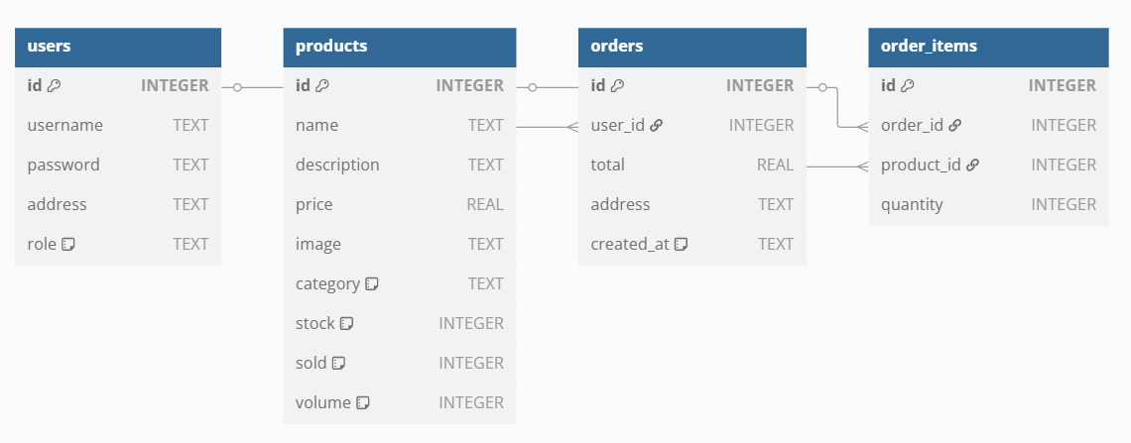

The diagram above shows the structure of the database used in the application. It has been designed to manage a simple system for handling users, products, and orders.

**Table Descriptions**

* **users**: Contains information about registered users, including their username, password, address, and role (with a default value of "user").
* **products**: Stores available products along with their details such as name, description, price, image, category, stock quantity, number of units sold, and volume.
* **orders**: Represents orders placed by users. Each record includes the total amount, delivery address, and a creation timestamp.
* **order_items**: Intermediate table linking orders to products, specifying the quantity of each product in a given order.

**Relationships Between Tables**

* A user can place multiple orders.
* An order can contain multiple products, and each product can appear in multiple orders. This many-to-many relationship is managed via the order_items table.

This relational design supports clear data organization and efficient handling of CRUD operations within the application.

**Image: DataBase exemple**

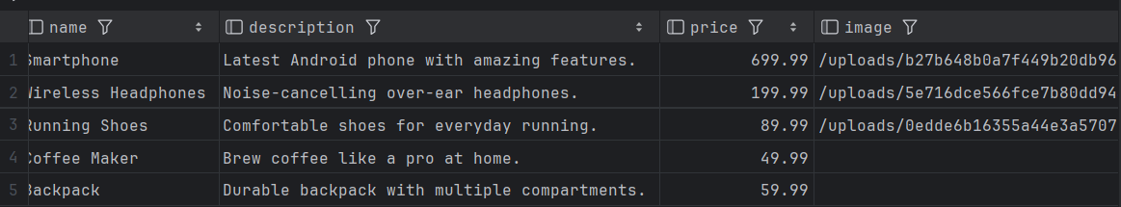

Here you can see an example of what the database looks like and the type of information it contains.  
It stores all the items sold on the website, including the product name, price, and image URL.

**Image: Code snippet**

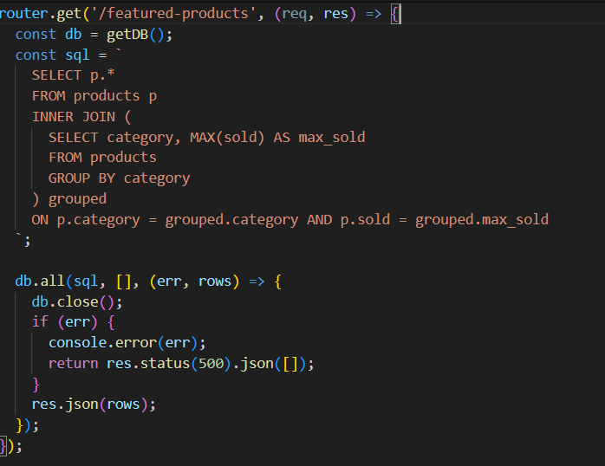

For example, this code retrieves data from the database to find the most popular product in each category. The result is stored in a variable and then sent as a JSON response.

In this case, the route is called /featured-products. So, if you go to your browser and visit the following URL:

**Image:** <http://localhost:3000/featured-products>

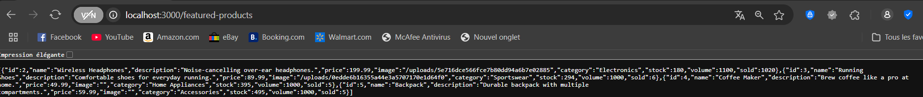

you'll see the JSON data directly in the browser.

This JSON can then be used however you want, such as fetching it from the frontend using JavaScript to display the featured products on your website.

**5.2 Team Member 2: Adel Leshob**

Adel Leshob focused on front-end development using HTML, CSS, and JavaScript to create a user-friendly and responsive interface. His work ensured that visitors could navigate the site smoothly across different devices.

**Image: HomePage view**

The image above shows the homepage as designed by Adel. It features a clear layout with easy access to the product catalog, shopping cart, and other key sections, following common e-commerce design principles.

Adel also implemented essential components like the product catalog, shopping cart, and checkout forms. The code snippet below demonstrates how these elements were built to interact with dynamic data, ensuring that product information and user details are displayed accurately.

**Image: Code snippet**

This snippet highlights the use of JavaScript and HTML to render dynamic content and manage user interactions, contributing to an intuitive and visually appealing experience.

|  |
| --- |
| **5.3 Team Member 3: Hugo Dos Reis** |

Hugo dos Reis was responsible for routing and integrating website components, using Express.js to manage API endpoints and connect the front-end with the back-end. He ensured features — from viewing products to placing orders — were accessible through properly structured routes. Hugo also maintained user session logic, keeping users connected throughout their experience.

Beyond routing, he managed the website’s security layer by implementing password hashing to securely store user credentials, a crucial step for safeguarding data and following best practices. Basic protections like input validation and session control were also applied to enhance the application’s integrity.

Hugo focused on core features, especially user authentication and account management.

|  |
| --- |
|  |

**Password Security:**

We use **bcrypt** in Node.js to securely hash user passwords before storing them. Bcrypt adds salt and applies a strong hashing algorithm, protecting passwords from being stored in plain text. The library is managed via the package.json file as a project dependency.

**Image: Dependencies**

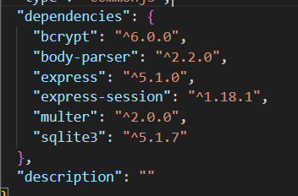

The above image shows the relevant part of the package.json file where bcrypt is listed as a dependency. This allows the Node.js environment to automatically install and update the library when setting up the project.

Now that you have this, the auth.js file we created will handle retrieving the password from the HTML form and then adding it to the database using bcrypt.

**Image: Password hashing Code**

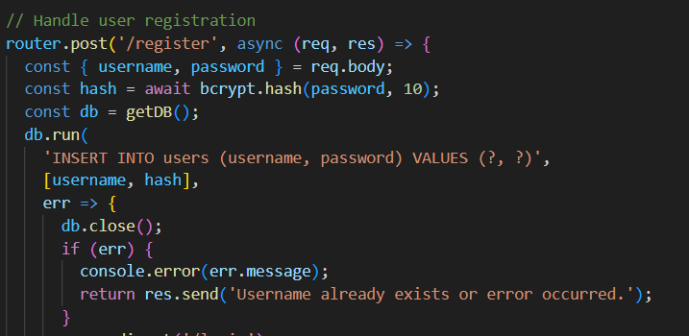

In this code snippet, you can see how the password is hashed asynchronously using bcrypt’s hash method with a specified salt round value. Once the password is hashed, it is ready to be saved securely to the database.

**Image: Password hashed**

The final image illustrates an example of the hashed password stored in the database. Notice that it appears as a long, complex string that cannot be reversed to retrieve the original password, providing strong protection for user credentials.

**Routing:**

Routing is a fundamental part of the web application, as it defines how requests from users are handled and which responses are sent back. In our project, the main routing control is centralized in the app.js file. This file acts as the entry point for all HTTP requests, directing them to the appropriate handlers based on the requested URL and method.

**Image: Routing and Connectivity Code**

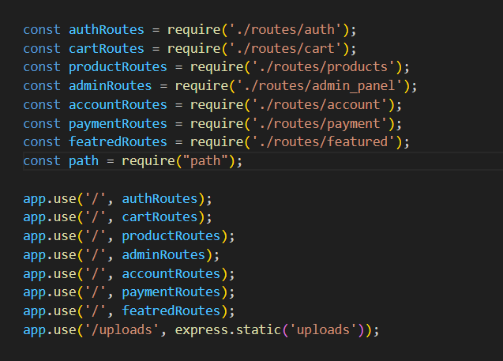

The image above shows a typical example of the routing setup in app.js. Here, Express.js is used to define routes that connect the front-end interface with the back-end logic. Each route corresponds to a specific feature, such as viewing products, managing user sessions, or processing orders.

While app.js manages the main routing setup, individual route handling is split across different files. Each module handles routes specific to its function, such as user authentication or product management. This modular structure keeps the code organized and simplifies development by isolating related routes.

|  |
| --- |
| **6. Conclusion and Future Perspectives** |

This e-commerce project was a good opportunity to practice full-stack web development using tools like Node.js, Express, JavaScript, SQLite, HTML, and CSS. The website includes important features such as a product catalog, shopping cart, user login, and a basic checkout process.

We built a simple and functional database, and the code works as intended, even if it could be improved for readability and organization. The design is basic but usable, and some adjustments may be needed for better responsiveness on all screen sizes.

Main features like product categories, shopping cart updates, and user accounts were implemented successfully. The optional admin panel was started and could be improved later. A test payment system was used, but the code is ready to connect to a real one in the future.

This project can be improved by adding stronger security, a better design, and more advanced features if needed.

Future improvements may include:

* Migrating to a more robust database solution for better scalability.
* Adding real-time features such as order tracking or live chat support.

Overall, this project serves as a strong foundation for building a professional e-commerce platform and demonstrates the practical application of modern web development practices.